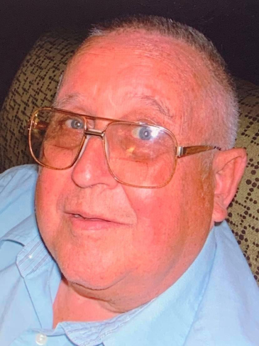

Don Henry
Distinguished Service Inductee

Don Henry represents the values of a Red Devil. As a lifelong community member and graduate from Holton High School, Mr. Henry’s dedication to the success of the school and the community as a whole is admirable. His contributions to the legacy of Holton Athletics began with him as an athlete. As a four sport athlete in football, basketball, baseball, and track his athletic talent was impressive. Mr. Henry was a part of the very first Holton Varsity Football Team in 1954. He and his teammates established a legacy that impacted the Holton community even to this day.

Don Henry’s legacy goes beyond the football field. Mr. Henry has remained a tremendous fan and supporter of Holton Athletics in the years following his time at Holton High School. He dedicated himself to serving in ways that make sure Holton athletes would get the chance to play by having support. For over thirty years, Don Henry ran the clock at every home boys basketball game Holton hosted. He dedicated his time volunteering to support these student athletes. Even though Mr. Henry might not have known every player, he knew that they were a part of the Red Devil family and in the same way he saw a community rally around a first time football team, he wanted to rally support with these athletes.

Don Henry stayed in the Holton community to raise his family. All of his children attended Holton making their own legacies. Don had a knack for missing team photos when he was a student at Holton. We will make sure he is in the photo this time.

Don Henry’s relentless and continued support of Holton Athletics and the Holton community as a whole make him very deserving of induction into the Holton Athletics Hall of Fame.

